Near By Places

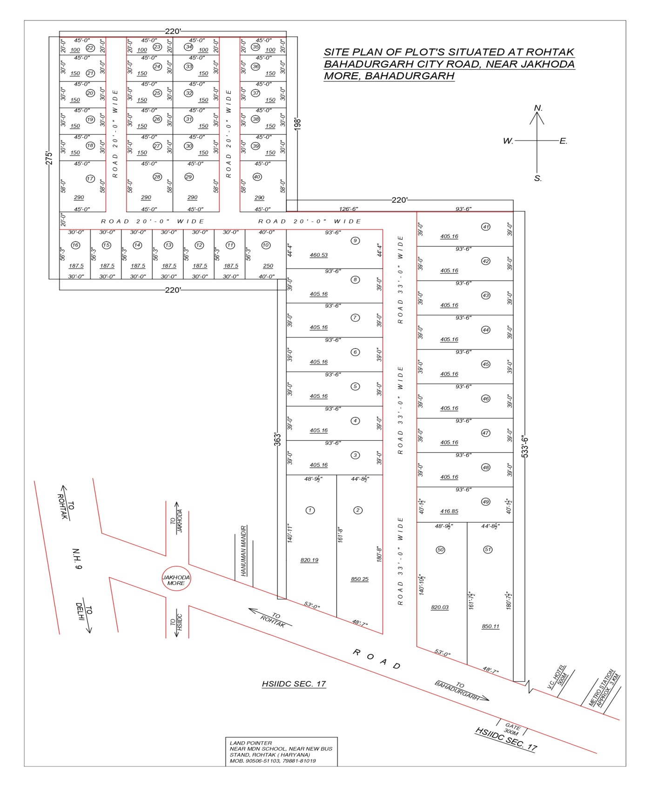

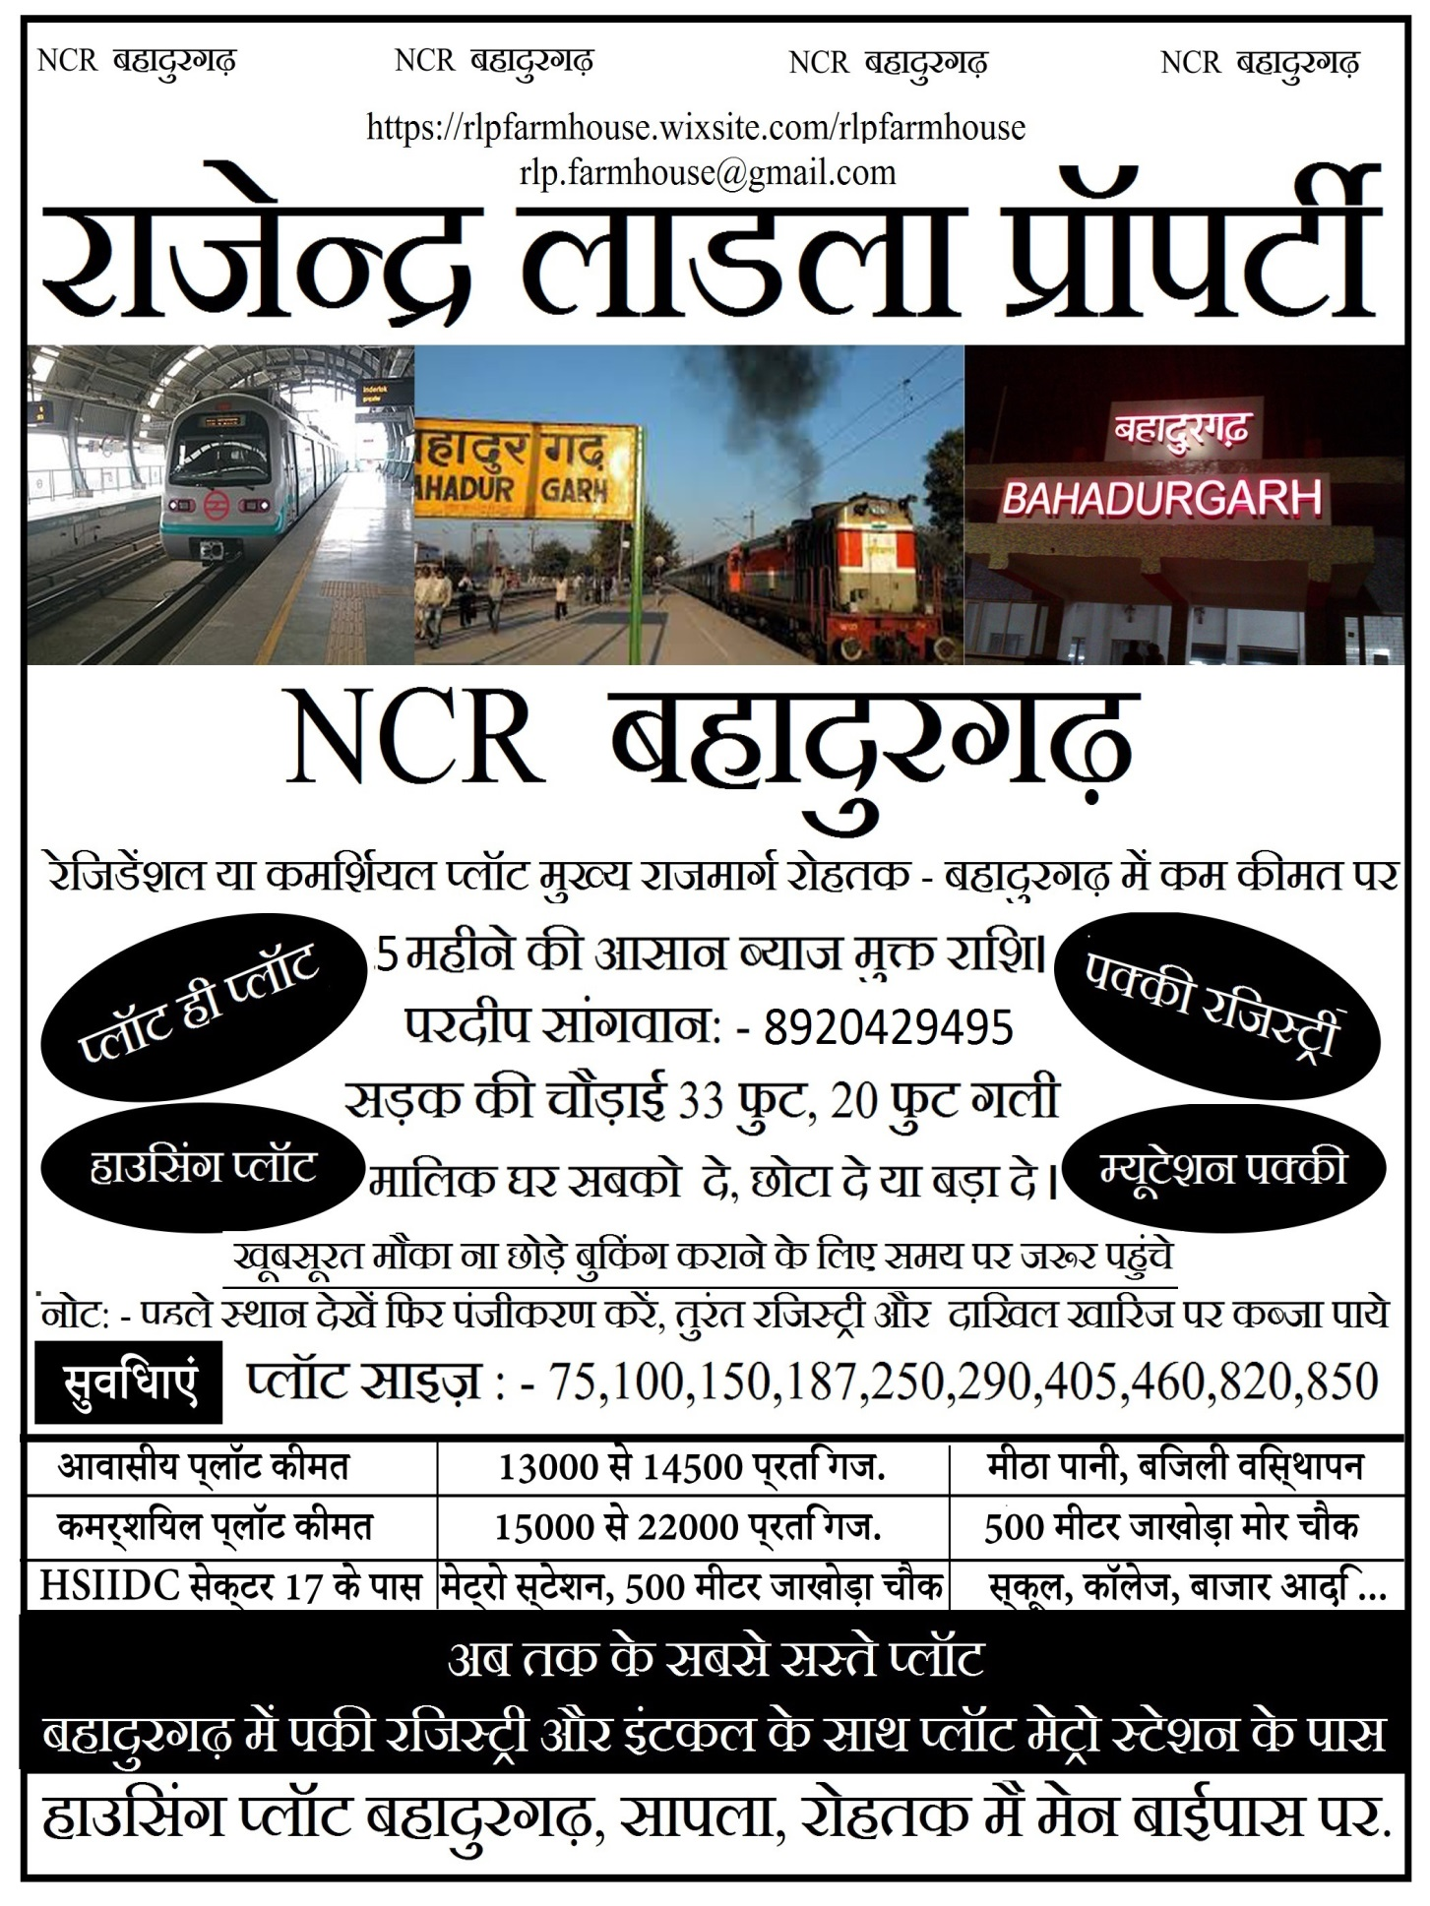Banks & ATMs

 ICICI BANK ATM (<6km)edit

 Axis Bank (<8km)edit

 Axis Bank ATM (<8km)edit

 State Bank Of India ATM (<4km)edit

 YES Bank ATM (<4km)edit

 PNB Bank Atm (<4km)edit

 ICICI BANK ATM (<5km)edit

 Axis Bank Atm (<5km)edit

 STATE BANK OF INDIA ATM (<6km)edit

 Axis Bank ATM (<6km)edit

 HDFC Bank ATM (<6km)edit

 Punjab National Bank ATM (<7km)edit

 YES Bank ATM (<7km)edit

 Equitas Small Finance Bank (<8km)edit

 STATE BANK OF INDIA ATM (<8km)edit

Education

 Scholars Global School Bahadurgarh (<7km)edit

 TRIVENI MEMORIAL SENIOR SECONDARY SCHOOL (<8km)edit

 Mount View Senior Secondary School (<7km)edit

 DAV Centenary Senior Secondary School Bahadurgarh (<7km)edit

 G N World School (<4km)edit

 Bal Vikas Senior Secondary School (<7km)edit

 Sunshine Public School (<4km)edit

 Radiant Public School Barahi (<5km)edit

 St. Thomas School (<5km)edit

 New Friends Primary School (<5km)edit

 Government Girls Primary School (<7km)edit

 Motheredit

 Lt. Mahipat Singh College Of Education (<5km)edit

 Little Shines-A Play School (<5km)edit

 Government Primary School Sector 6 (<6km)edit

 GSV Classes (<6km)edit

 Bal Vikas Sr. Sec. School (<6km)edit

 AAKASH INTERNATIONAL SCHOOL (<6km)edit

 Sunshine Public School (<6km)edit

 Adarsh High School (<8km)edit

Recreation

 Corona arcade (<10km)edit

 Ram Cinema (<8km)edit

 Shivalik Cinema (<8km)edit

 Kundan Cinema (<8km)edit

 SKS Music Bhojpuri (<9km)edit

 Rana Bhawan (<9km)edit

 Cine Time Bahadurgarh (<10km)edit

 Movietime: Corona Arcade Mall Bahadurgarh (<10km)edit

Hospitals & Healthcare

 Odontogenica-Dental & Oral Cancer Clinic (<6km)edit

 Tanish Dental Hospital (<7km)edit

 Tishlar Super Speciality Dental Clinic (<8km)edit

 Krishna Dental Clinic (<8km)edit

 dr Batraedit

 My Doctor (<8km)edit

 Dental clinic (<8km)edit

 Eye Max Eye & Dental Care Hospital (<8km)edit

 Dr. Manohar Dental Clinic (<8km)edit

 SJS Memorial Dental Care Centre (<8km)edit

 Sanjeevani Dentals (<8km)edit

 Harsh Dental Hospital (<8km)edit

 Mahindra Dental Clinic (<8km)edit

 V Care Dental Clinic (<8km)edit

 Upkar dental clinic (<8km)edit

 Ganesh Dental Clinic (<8km)edit

 Smile Dental Clinic (<8km)edit

 Kalawati Dental Hospital (<9km)edit

Restaurants & Clubs

 Layers - Cakes N Goodies (<8km)edit

 Frontier Biscuit (<12km)edit

 Brotheredit

 Spicy Dream (<5km)edit

 Junction Cafe (<7km)edit

 Jai Mata Di Confectionery (<7km)edit

 Dev Confectionery (<7km)edit

 Bimbo cakes & Cafe (<8km)edit

 Papaedit

 Rajendra biscuit bakery (<8km)edit

 Goyal bakers (<8km)edit

 Mahesh pastry shop (<8km)edit

 Bansal Bakery (<8km)edit

 Siyaram Confectionery (<8km)edit

 Bansal Bakers (<8km)edit

 DURGA CONFECTIONERY (<8km)edit

 Parkash Agencies (<9km)edit

 Singhal Bakery (<9km)edit

 PAN BAKERS (<9km)edit

 Pan Bakeredit

Hotels & Guest Houses

 Motel Gajraj Continental (<2km)edit

 Haryana Tourism- Gauriyya Hotel And Restaurant (<6km)edit

 Hotel VC (<2km)edit

 Gajraj Motel (<2km)edit

 The Club Platinum Resort (<5km)edit

 Business Conference Hall Bahadurgarh (<8km)edit

 Dm Ventilation Sys India(P)Ltd (<13km)edit

 HVPNL (<2km)edit

 Vikram Dalal and Sons paying guest (<2km)edit

 Shri Krishna PG & DharamKanta (<2km)edit

 Gayatri Mandir Jamdagni (<3km)edit

 HOTEL EMMKAY RESIDENCY (<3km)edit

 Shivam P.G (<3km)edit

 Dada Shyam lal Villa (<3km)edit

 Omaxe Subhaangan (<3km)edit

 Pooja Pg Omaxe City (<3km)edit

 Omaxe City North Avenue 2 - 3BR (<3km)edit

 Royal Street (<3km)edit